1.

For this week, I learned the concept of monolithic, microservices, and how to work with Docker – these are equally important to me at the moment since I currently taking another cloud-related unit as knowledge gained from both help strengthen my foundation upon cloud technology much better through constant exposure.   
By having a fresh understanding of both monolithic and microservices, I could start reading “Designing Data-Intensive Applications” book and grasp it at a faster rate than I used to be before. As for Docker, I only know it briefly not but detail like its mechanisms, how does it contribute to the overall process of an application / software, etc … (or a.k.a why it is widely used globally).

2.

Task 1 – Learn by doing

I found that I have 3 images of hello-world (peaceful_mcnulty, zen_goodall, vibrant_driscoll) so I wen ahead logs, restart then remove them from the list displayed from “docker ps -a”.

Task 2 - Update the container image

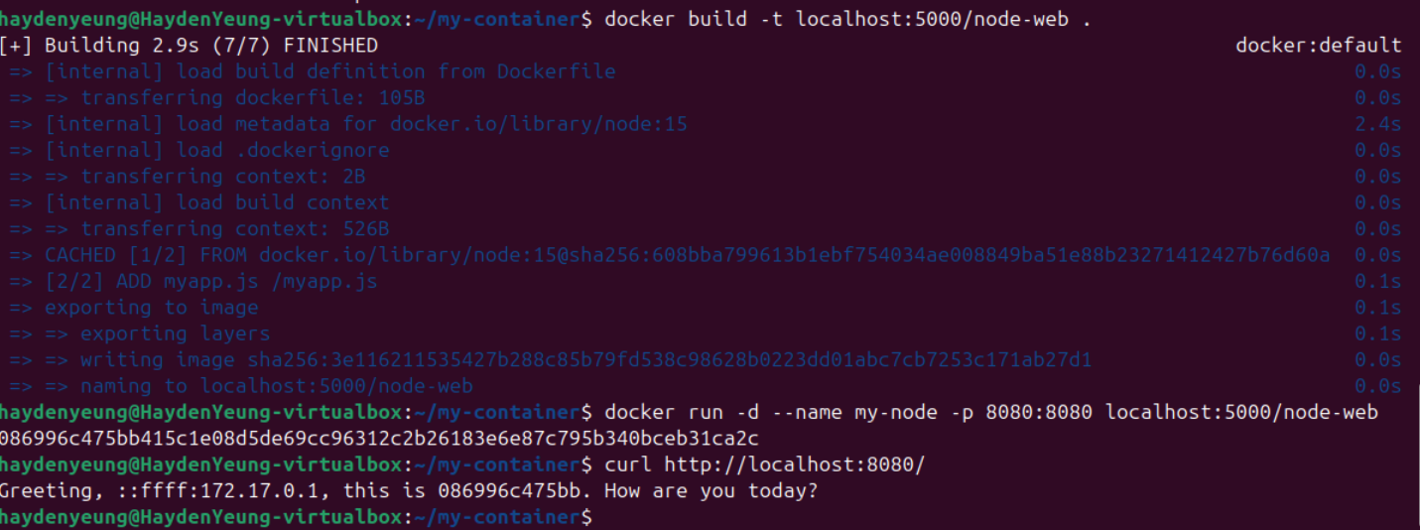

I simply change the text display of console.log() and res.end. Since I still fresh with backend (node.js) so I would stop here.

3.

​Capital Expenditure (CapEx) and Operational Expenditure (OpEx) are two primary categories of business expenses, each with distinct financial implications. CapEx refers to the funds a company uses to acquire, upgrade, or maintain physical assets such as property, industrial buildings, or equipment. These are substantial, upfront investments that provide value over time and are typically capitalized on the balance sheet and depreciated over the asset's useful life. For example, purchasing servers for an on-premises data center is considered a CapEx investment (Watts, 2025; Wikipedia, n.d.).

OpEx, on the other hand, encompasses the ongoing costs associated with the daily operations of a business. These expenses are fully deducted in the accounting period they are incurred. Examples include salaries, utilities, and rent. In the context of IT infrastructure, subscribing to cloud services falls under OpEx, as businesses pay regular fees for the services they consume without significant upfront investments (GeeksforGeeks, 2023; Watts, 2025).

When comparing locally hosted infrastructure to cloud computing, the distinction between CapEx and OpEx becomes particularly significant. Deploying and maintaining on-premises infrastructure requires substantial CapEx, as organizations must invest in hardware, software licenses, and facilities. Additionally, they incur ongoing OpEx for utilities, staffing, and maintenance. This model can tie up capital and may lead to underutilized resources if capacity planning is not optimal (Watts, 2025).

Conversely, cloud computing operates on a pay-as-you-go model, aligning with OpEx. Companies can scale resources up or down based on demand, paying only for what they use. This approach offers financial flexibility, reduces the need for large upfront investments, and allows organizations to respond swiftly to changing business needs. However, it is essential to monitor usage to prevent unexpected costs (Lovett, 2023).

In summary, CapEx involves significant upfront investments in physical assets, typical of locally hosted infrastructures, while OpEx pertains to ongoing operational costs, characteristic of cloud computing services. The choice between these models depends on an organization's financial strategy, scalability requirements, and capacity to manage IT resources.

**References**

GeeksforGeeks. (2023). *CapEx vs OpEx in cloud computing*. Retrieved March 22, 2025, from https://www.geeksforgeeks.org/capex-vs-opex-in-cloud-computing/

Watts, S. (2025, January 29). *CapEx vs. OpEx for cloud, IT spending, and business operations*. Retrieved March 21, 2025, from <https://www.splunk.com/en_us/blog/learn/capex-vs-opex.html>

Lovett, C. (2023, January 18) *CapEx vs OpEx: IT spending and the cloud*. Retrieved March 22, 2025, from https://www.tierpoint.com/blog/capex-vs-opex-cloud-whats-the-difference/

Wikipedia. (n.d.). *Capital expenditure*. Retrieved March 22, 2025, from <https://en.wikipedia.org/wiki/Capital_expenditure>

4.

Many organizations prefer Operational Expenditure (OpEx) over Capital Expenditure (CapEx) because it offers financial flexibility and reduces the burden of large upfront costs. Instead of making a significant investment in hardware and infrastructure, businesses can opt for a pay-as-you-go model, which allows them to scale resources as needed and keep cash flow more predictable (BCS365, 2022). This approach is particularly beneficial for companies looking to remain agile in a fast-changing market, as it frees up capital for innovation and other strategic initiatives (Ewoldt B., 2024).

However, shifting from locally hosted infrastructure to cloud services introduces new risks. One key challenge is the loss of direct control over IT assets and security, as cloud providers manage most of the infrastructure (Flexential, 2023). This can make it harder for businesses to monitor performance and ensure compliance with internal security policies. Additionally, cloud migration may expose organizations to data breaches or service disruptions if not handled properly, making risk assessment and strategic planning essential (Morrow, T. 2018).

**References**

BCS365. (2022). *Benefits of shifting your CapEx to OpEx with cloud computing*. Retrieved March 21, 2025, from <https://bcs365.com/insights/benefits-of-shifting-your-capex-to-opex-with-cloud-computing>

Flexential. (2023, June 27). *Cloud migration risks & mitigation strategies*. Retrieved March 21, 2025, from <https://www.flexential.com/resources/blog/how-mitigate-risk-cloud-migration-strategies>

Ewoldt, E. (2024, February 13). *Cloud migration: How innovative companies are moving to the cloud*. Retrieved March 21, 2025, from <https://www.ntiva.com/blog/cloud-migration-why-companies-are-moving-to-the-cloud>

Morrow, T. (2018, March 5). *12 Risks, Threats, & Vulnerabilities in Moving to the Cloud.* Retrieved March 21, 2025, from https://insights.sei.cmu.edu/blog/12-risks-threats-vulnerabilities-in-moving-to-the-cloud/.